

**Human Computer Interaction**

**Meeting and Online Lectures App**

Wasif Mairaj - 62973

Alina Hussain - 63344

Naveed Ali Shah - 63374

Class ID: 104496

**Project Proposal**

Submitted to: **Ma’am Afshan Saad**

**ABSTRACT**

Advances in digital technology are bringing qualitative analysis new possibilities. Among these, the online meeting application is an innovative videoconference platform with a number of unique features that enhance its potential appeal to researchers with both qualitative and mixed methods. Application for meetings became almost synonymous with office meetings and socializing as people are around the world have adapted to life at home amid the coronavirus outbreak. This project will focus on the use of online learning to build the capacity of the learning environment to provide quality professional development to enable moderators and teachers to integrate technology into the curriculum to meet standards. This online application aims to improve student achievement through the use of technology, to raise student technology literacy, and to ensure that teachers integrate technology into the curriculum effectively.

**TASK ANALYSIS**

**MAIN ACTORS ROLE**

Following are the ‘3’ major actors for the proposed system:

1. Students
2. Teacher
3. Moderator

Main purpose of these following actors are discussed below:

**Student Side:**

1. Students can register and sign up through email (i.e Gmail ,Facebook etc) and join through meeting.
2. The system given an option to student to check the history of their quizzes, tasks and obtained marks.
3. The program offers users the option to connect their MIS / LMS account to our app to take online classes.
4. Students have the choice of lifting their hands and they may pose questions.
5. Students can view and download the study material which the faculty uploads.
6. Students can time mark their attendance while logging in from their respective LMS / MIS accounts.
7. Students can also access the books of library as per their choice.
8. Student can type any query which he or she want’s to ask to there lecturer by typing.
9. Student can ask query by opening there mic or by rising hand option.
10. Student can upload there profile pictures.
11. Students can set there user name before joining the meeting.
12. Student can see the previous record of the meeting.
13. Student can mute and unmute them selves if they wants to ask question.
14. Students can on there video if they wants to give any presentation or project evolution.

**Moderator Side:**

1. Moderator can define mutual settings for both the user, i.e. teacher and student.
2. Moderator can maintain login/logout logs, attendance report, and class timings.
3. Moderator is required to accept the joining request of the students so that the flow of the class and teacher is not affected.
4. Moderator can record the lectures that will be automatically available in History Section for both the users i.e. Teacher and Students.
   1. Moderator has the rights to remove any of the student, if he found disturbing the class.
5. Moderator is responsible for the material that is outside the course, he can upload all the Books and Thesis in Library Section, and also can manage its record.
6. Moderator can change the password of ids for both the users.

**Teacher Side:**

1. In teacher panel, teacher can answers the queries asked by the students.
2. Teacher can provide all the material related to his course in the same app with respect to Upload Date.
3. The app will have a feature for the teacher, if a student doesn’t reply any question asked by the teacher or did not participate in the lecture for a specific time, the app will automatically put the student profile in “Sleepy Students” , which can be managed by the teacher.
4. The teacher can receive answer by the students in term of voice, and can also solve some problems on virtual white board by the students.
5. Teacher can share screen or can share a specific part of the screen.
6. The starting and ending time of class will be stored in logs which can be viewed by the moderator.
7. Teacher can conduct quiz, MCQs based as well as DQA’s based.
8. Teacher can mark quizzes and assignment on the same proposed system, which will be shown to the students.
9. Teacher can admit or remove the joining request of the participants.
10. Teacher can lock the meeting session also so no outsider can join the session.
11. Teacher can remove the participant if he or she is disturbing the class.
12. Teacher can share the screen.
13. Teacher can record there lecture.
14. Teacher can create the meeting and update or change the password also.
15. Teacher can set the security also who can share there screen or who can unmute themselves and speak through mic.
16. Teacher can also set the chat box privacy (i.e:Everyone,only me,or Participants who has joined the session)
17. Teacher can see who wants to ask question by raising hand option.
18. Teacher and students can attached links and send the photos also.
19. Teacher can also mute and unmute the participants.

**MAIN FEATURES:**

1. Join from anywhere on any device.
2. Access robust security solutions throughout.
3. Built-in tools for screen sharing.
4. HD video and audio calls.
5. Identify lazy students easily.

**PROBLEM ADDRESSED:**

According to some technology analysts, the greatest obstacle to meeting application going forward is not about solving those issues. It is doing it in a way that helps meeting application to retain the simplicity that first made it so popular. Cybersecurity cases are increasing by 82.5%. MORE people are online now – whether for business, education , entertainment, socializing or working from home because of the control of movement order. 18% or 152 cases involved local companies, while the rest were home users and others.

**USECASE:**

**Teacher Side:**

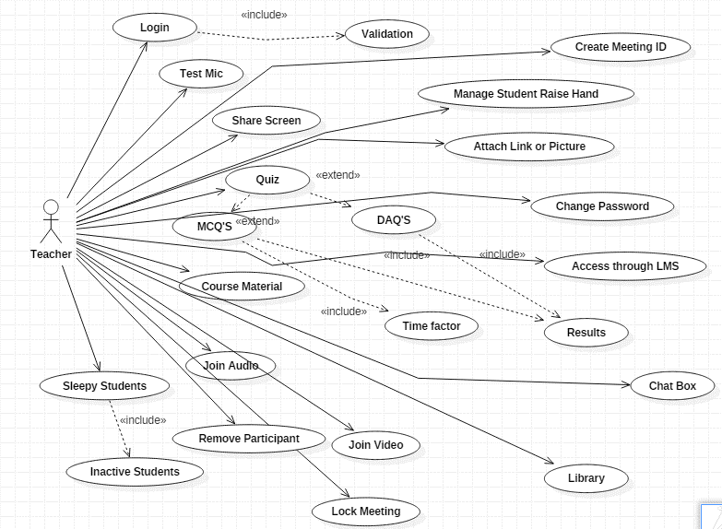

**Student Side:**

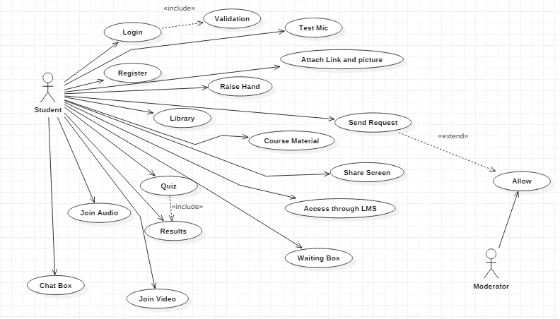

**Moderator Side:**

